**14-Oct-2024**

**Internship Day – 60 Report:**

**Sets in Python**

A set in Python is an unordered collection of unique items. Sets are a built-in data type that provides a way to store multiple items in a single variable while ensuring that each item is unique (i.e., no duplicates). Sets are mutable, meaning you can add or remove items after the set is created.

**Characteristics of Sets**

* **Unordered:** The items in a set do not have a defined order, and you cannot access items by index.
* **Unique:** Each item in a set must be unique; duplicate items are not allowed.
* **Mutable:** You can add or remove items from a set, but the items themselves must be immutable types (like numbers, strings, or tuples).
* **Dynamic:** Sets can grow and shrink as you add or remove items.

**Creating a Set**

You can create a set by placing comma-separated values inside curly braces {} or by using the set() constructor.

**Example:**

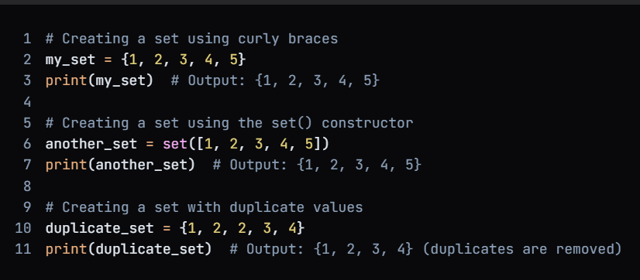

**Tuples in Python**

A tuple in Python is a built-in data structure that is used to store a collection of items. Tuples are similar to lists but have some key differences. They are immutable, meaning that once they are created, their contents cannot be changed. This makes tuples useful for storing data that should not be modified.

**Characteristics of Tuples**

1. **Ordered:** Tuples maintain the order of elements. The items can be accessed by their index, which starts at 0.
2. **Immutable:** Once a tuple is created, you cannot modify its contents (i.e., you cannot add, remove, or change items).
3. **Heterogeneous:** Tuples can contain items of different data types, including numbers, strings, lists, and even other tuples.
4. **Dynamic:** While the contents of a tuple cannot be changed, you can create new tuples from existing ones.

**Creating a Tuple**

You can create a tuple by placing a comma-separated list of values inside parentheses ().

**Example:**

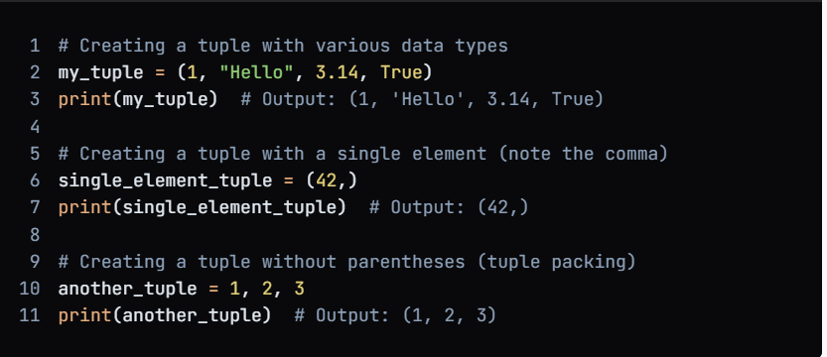

**15-Oct-2024**

**Internship Day – 61 Report:**

**Dictionaries in Python**

A dictionary in Python is a built-in data structure that allows you to store data in key-value pairs. Dictionaries are mutable, unordered collections that can hold a variety of data types, including other dictionaries, lists, and tuples. They are often used to represent structured data and provide fast access to values based on their keys.

**Characteristics of Dictionaries**

* **Key-Value Pairs:** Each item in a dictionary is stored as a pair, consisting of a key and a value. The key must be unique and immutable (e.g., strings, numbers, or tuples), while the value can be of any data type and can be duplicated.
* **Unordered**: Dictionaries do not maintain the order of items. However, as of Python 3.7, dictionaries preserve the insertion order of keys.
* **Mutable:** You can change, add, or remove items from a dictionary after it has been created.
* **Dynamic:** The size of a dictionary can change as you add or remove key-value pairs.

**Key Features of Python**

1. **Easy to Learn and Use:** Simple and readable syntax.
2. **Interpreted Language:** Code is executed line by line, facilitating debugging.
3. **Dynamically Typed:** Variable types are determined at runtime.
4. **Object-Oriented:** Supports encapsulation, inheritance, and polymorphism.
5. **Extensive Standard Library:** Rich set of modules and functions for various tasks.
6. **Cross-Platform Compatibility:** Runs on multiple operating systems without modification.
7. **Support for Multiple Programming Paradigms:** Supports procedural, object-oriented, and functional programming.
8. **Community and Ecosystem**: Large, active community with abundant resources and libraries.
9. **Integration Capabilities**: Easily integrates with other programming languages.
10. **Rich Ecosystem of Third-Party Libraries:** Vast collection of libraries available through PyPI.
11. **Generators and Iterators:** Efficient looping over large datasets without consuming memory.
12. **List Comprehensions:** Concise and readable way to create lists.
13. **Exception Handling**: Robust mechanism for managing errors gracefully.
14. **Decorators:** Modify the behavior of functions or methods.

**16-oct-2024**

**Internship Day - 62 Report:**

**What is Chocolatey:**  
  
Chocolatey is a package manager for Windows that makes it easier to install, update, and manage software. Here's a clear explanation:

**Core Concepts:**

* A command-line package manager similar to apt-get (Linux) but for Windows
* Automates software installation, updates, and uninstallation
* Uses PowerShell to execute commands
* Manages dependencies automatically

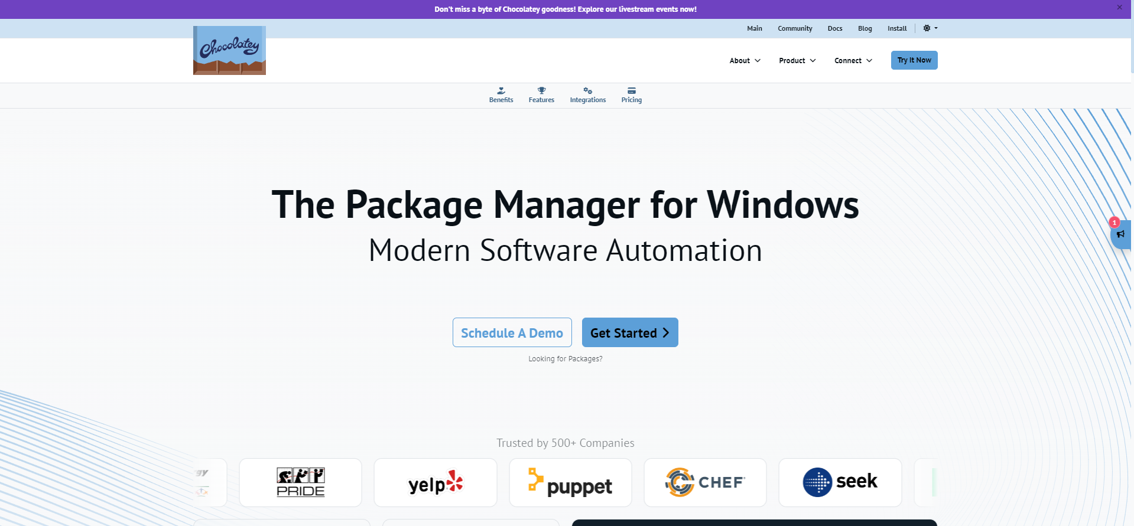

**Key Features:**

1. **Installation Management:**

* Simple commands like choco install firefox
* Can install multiple packages at once
* Handles software dependencies automatically
* Silent installations (no clicking through installers)

1. **Common Commands:**

* choco install packagename - Install a package
* choco uninstall packagename - Remove a package
* choco upgrade packagename - Update a package
* choco list - Show installed packages
* choco search term - Search for packages

1. **Benefits:**

* Saves time on software installation
* Consistent installation process
* Easy system maintenance
* Can script installations for multiple computers
* Access to thousands of software packages

**STEPS TO INSTALL CHOCOLATEY ON WINDOWS:**

**1. Open PowerShell as Administrator** (right-click Windows PowerShell and select "Run as Administrator")

1. **First, check your execution policy by running:  
     
   COMMAND**: Get-ExecutionPolicy

1. **If it's restricted, run:  
     
   COMMAND**: Set-ExecutionPolicy AllSigned  
     
   
2. **Run this command to install Chocolatey:**
3. **Wait for the installation to complete**
4. **Verify the installation by running:**

**COMMAND**: choco –version

**What is GitBash:**

GitBash is a command-line interface for Windows that provides a Unix-like shell environment, combining Git functionality with traditional Bash commands. It enables users to interact with Git repositories while using familiar Unix commands on Windows systems.

**Key Features:**

* Unix-style command-line environment for Windows
* Built-in Git commands integration
* BASH emulation for Windows
* SSH client and key generation
* Unix tools packaged for Windows

**Essential GitBash Commands:**

**1. Basic Navigation:**

* pwd - Current directory
* ls - List files
* cd - Change directory
* mkdir - Create directory

**2. File Operations:**

* touch - Create empty file
* rm - Remove files
* cp - Copy files
* mv - Move/rename file

**STEPS TO INSTALL GITBASH USING CHOCOLATEY:**

**1. Open PowerShell as Administrator and run:**

COMMAND: choco install git.install (this command for install both git and bit bash)

**2. Verify the installation:**

COMMAND: git –version

**Introduction to Vagrant**

Vagrant is a powerful tool used to build and manage virtualized development environments efficiently. By providing a consistent, reproducible environment, it eliminates the common "it works on my machine" issue, making collaboration easier.



**Why Use Vagrant?**

* **Ease of Setup:** Simplifies and automates the setup of development environments, reducing time and effort.
* **Cross-Platform Compatibility:** Works on Windows, macOS, and Linux, ensuring consistent development environments across teams.
* **Portable and Reproducible:** Configurations are defined in a single `Vagrantfile`, making it easy to reproduce environments.

**Core Features**

* **Provider Agnostic:** Supports various providers like VirtualBox, VMware, AWS, and more.
* **Provisioning Tools:** Integrates with provisioning tools like shell scripts, Chef, and Puppet to automate software configuration.
* **Single Workflow:** Manages virtual machines through a simple workflow (`vagrant up`, `vagrant halt`, etc.), streamlining the process for all users.

**Benefits by Role**

**1. For Developers:**

* **I**solates dependencies and configurations in a consistent environment.
* Enables easy setup across teams, ensuring everyone works in the same environment.
* Reduces bugs due to environmental differences.

**2. For Operators (DevOps):**

* **O**ffers a disposable environment for testing infrastructure management scripts (e.g., shell, Chef, Puppet).
* Supports testing on local and cloud environments (e.g., AWS) using the same configuration.

**3. For Designers:**

* Simplifies the setup of web applications, allowing designers to focus on design without worrying about setup.
* Eliminates dependency on developers for environment fixes.

**INSTALLATION OF VAGRANT USING CHOCOLATEY:**

1. **Before install vagrant on your system you have to install virtualbox**:

COMMAND: choco install virtualbox -y

1. **Install Vagrant using Chocolatey:**

COMMAND: choco install vagrant -y

1. **Verify the installation:**

COMMAND: vagrant –version

**18-Oct-2024**

**Internship Day – 63 Report:**

**Basic Vagrant commands to get started:**

* **mkdir vagrant-vms** - Used to Create a directory for your project.



* cd vagrant-vms



* **vagrant init ubuntu/jammy64** - Initialize Vagrant with a base box (Ubuntu in this example).

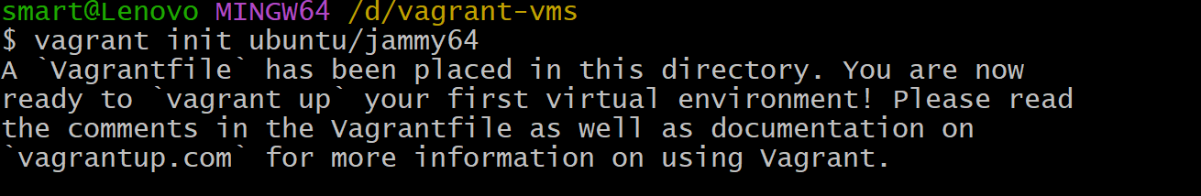

* **vagrant up** - It is used to start and provision a virtual machine based on the configuration defined in the Vagrantfile.

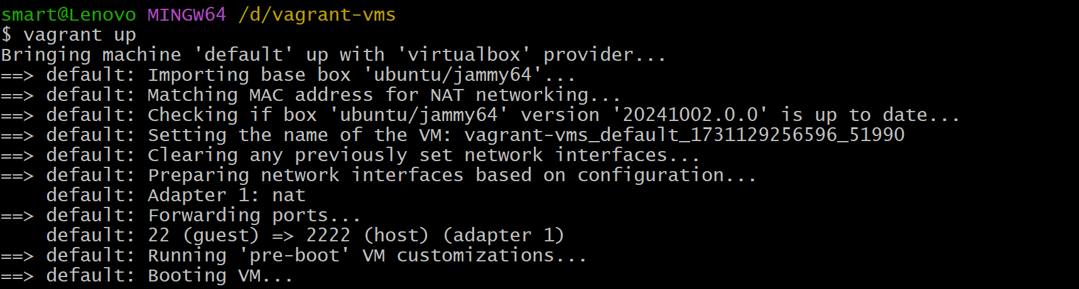

* **vagrant ssh** - To connects you to the VM that has been created and is currently running.



* **vagrant destroy** - It is used to completely remove the virtual machine and its associated resources.

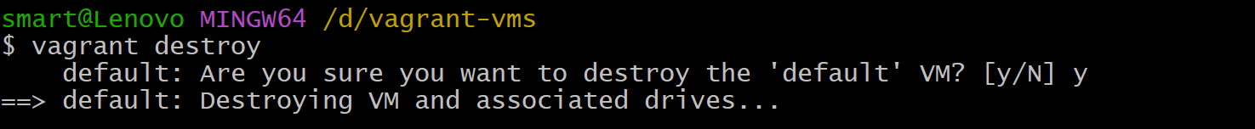

* **vagrant status** - It shows the current state of the virtual machine, indicating whether it is running, stopped, or in another state.

